***A COMPREHENSIVE ANALYSIS OF FINANCIAL PERFORMANCE : INSIGHTS FROM A LEADING BANKS***

***1.Introduction:***

* 1. ***Overview:***

This session introduces bank financial statement and provides a traditional,ratio-base procedure for analyzing bank financial performance using historical data. It demonstrates the interrelationship between the income statement and balance sheet and describes the risk and return trade-off underlying management decisions. Data are provided that compare the performance characteristics of small banks verus large banks and differentiate between high and low performance.

* 1. ***PURPOSE:***

Financial performance analysis is multifaceted approach to evaluating a company’s financial performance. It is the process of examining a business enterprise’s financial records,statement ,tools,and process. Here are some of the things financial performance analysis looks at:

* Working capital: It is the difference between the companies’ current assets and liability.
* Financial structure: It is the mix of equality and other portfolios offered by the company.
* Analyzing activities: It analyses business functions like costing, pricing,accounts,etc.

**2.PROBLEM DEFINITION AND DESIGN THINKING**

**2.1 Empathy Map:**

The empathy map is given below:

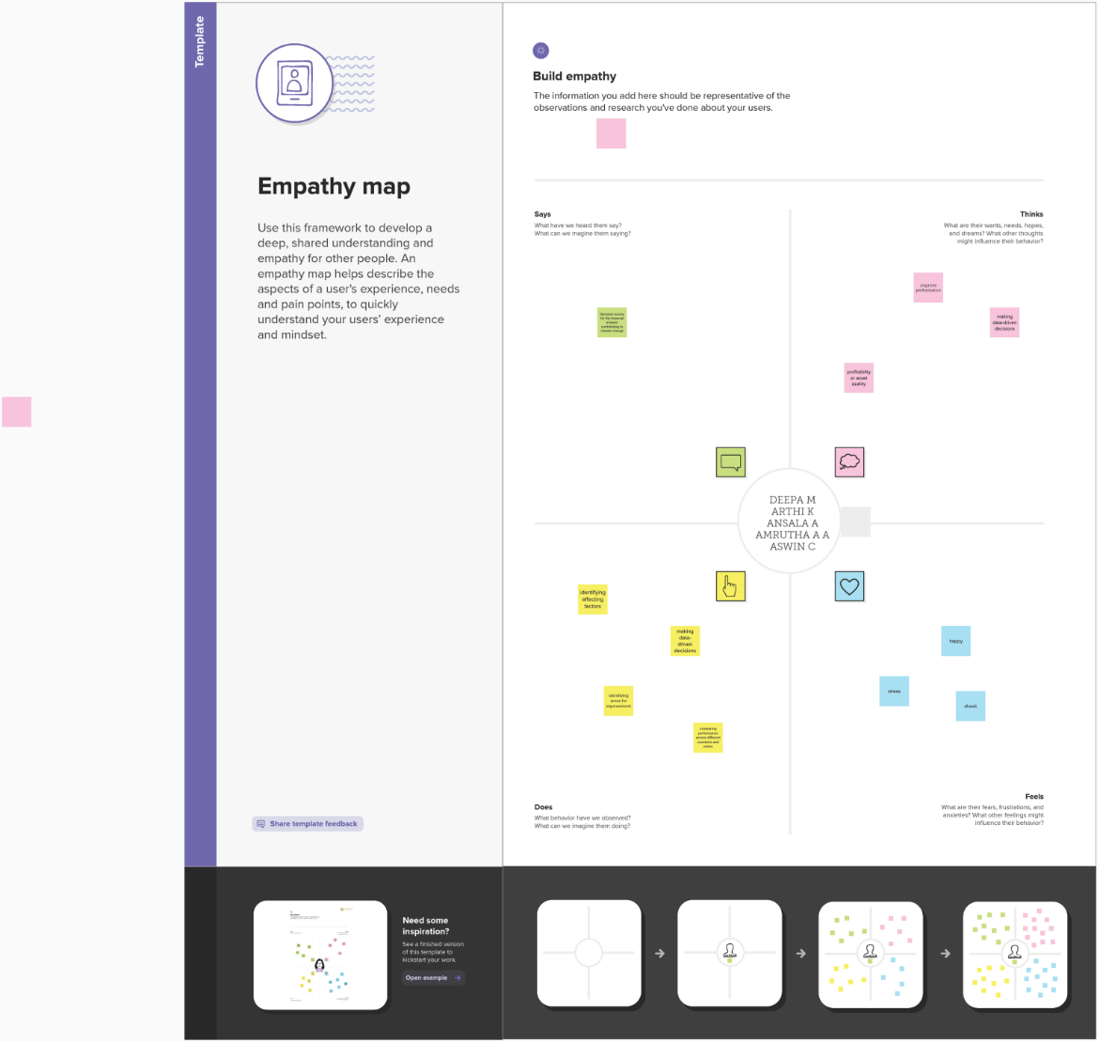

2.2 Ideation and Brainstorming Map:

The brainstorming map is given below:

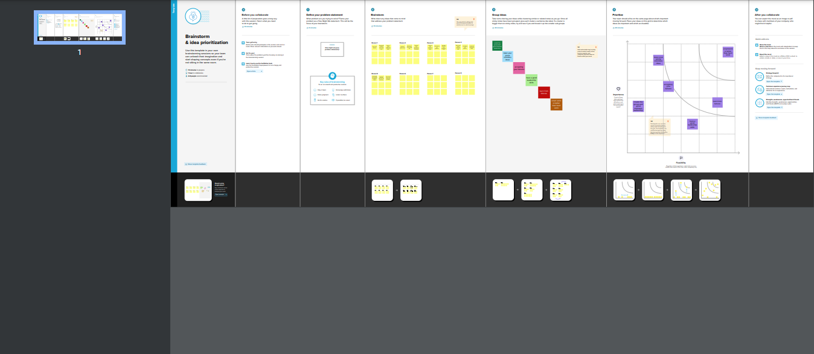

**3 . Result:**

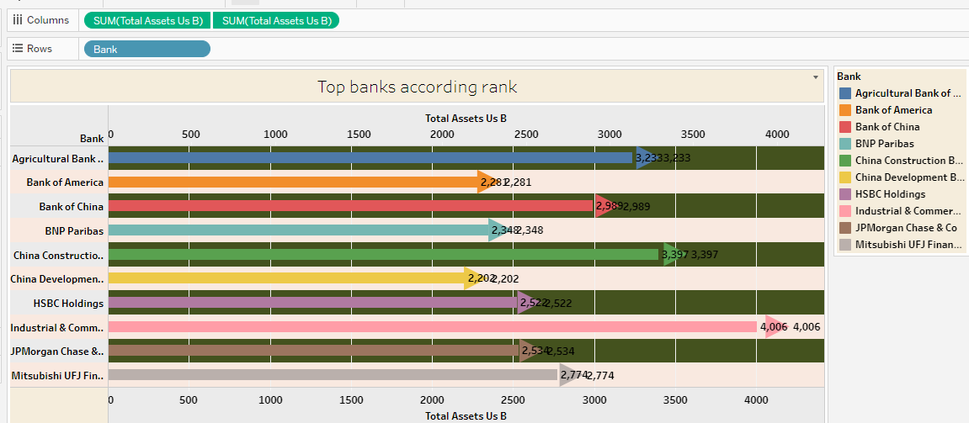

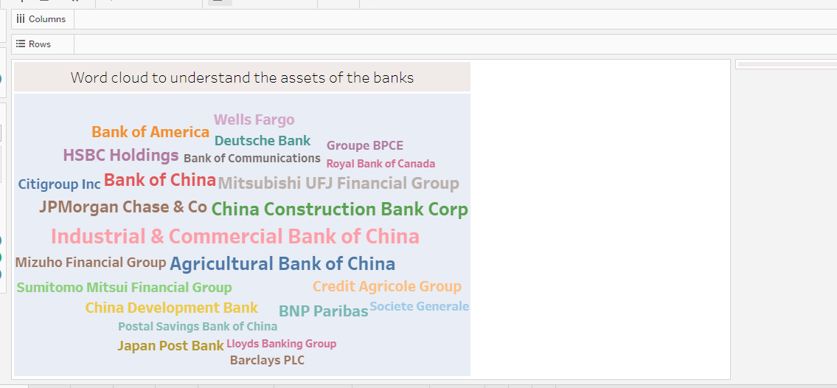

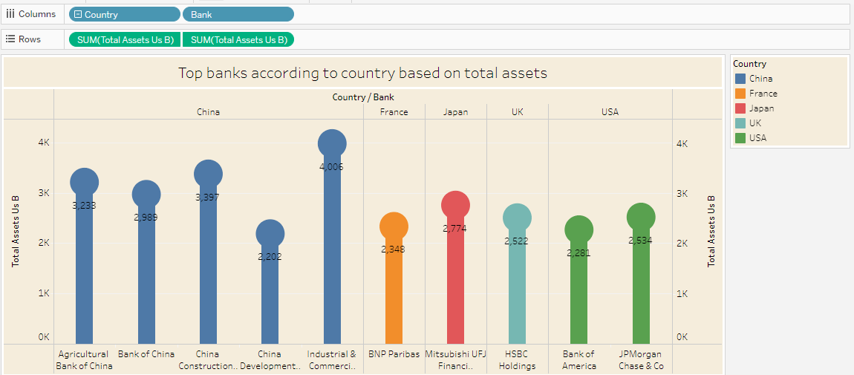

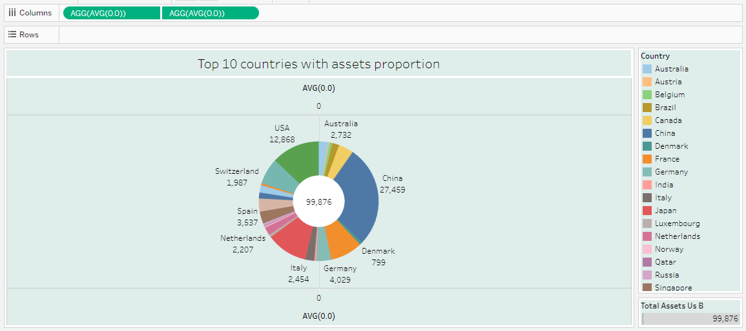

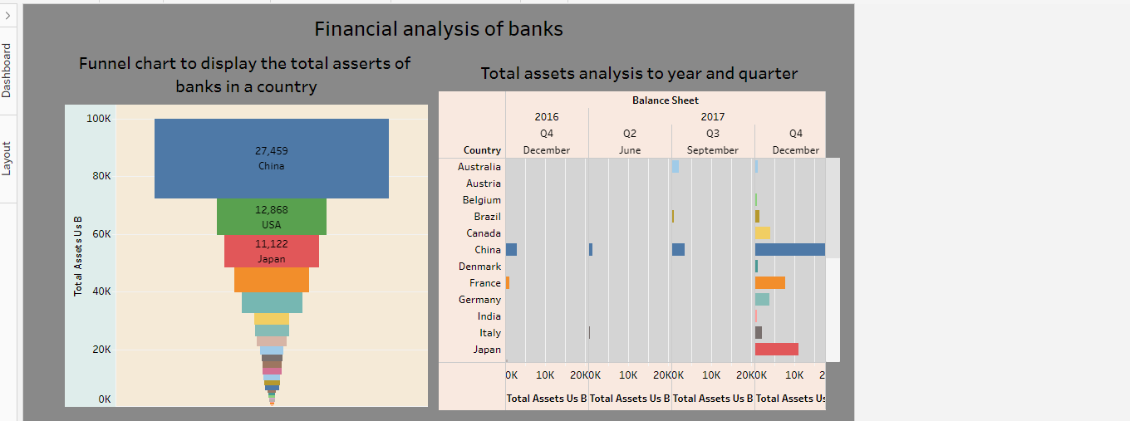

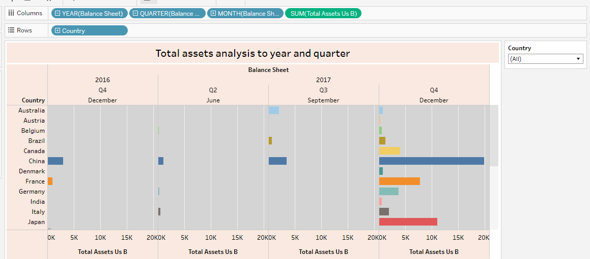

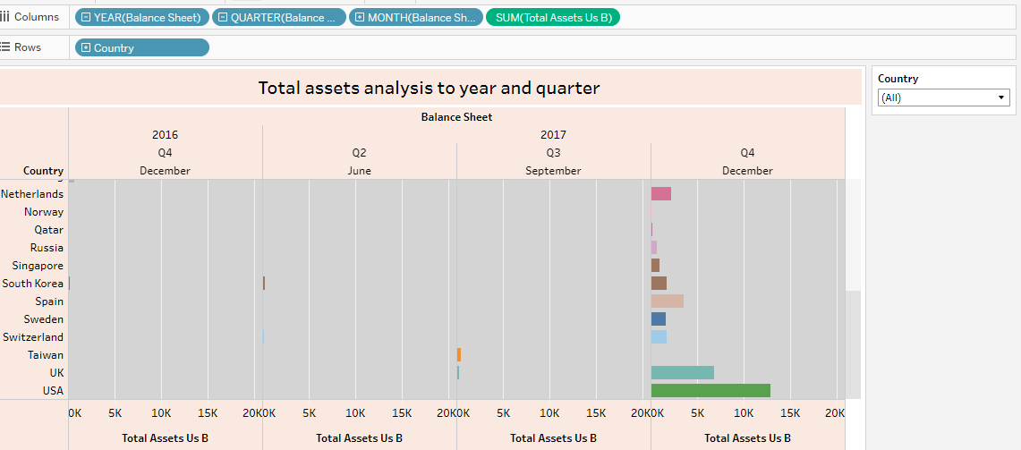

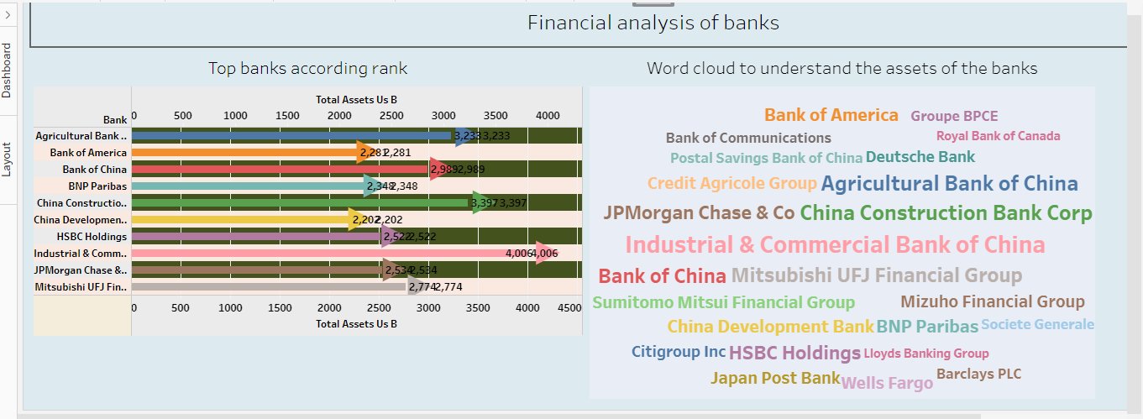

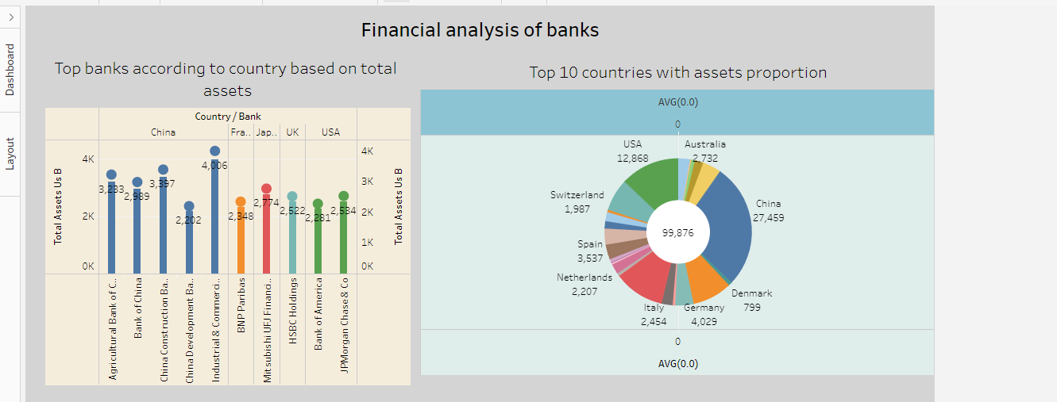

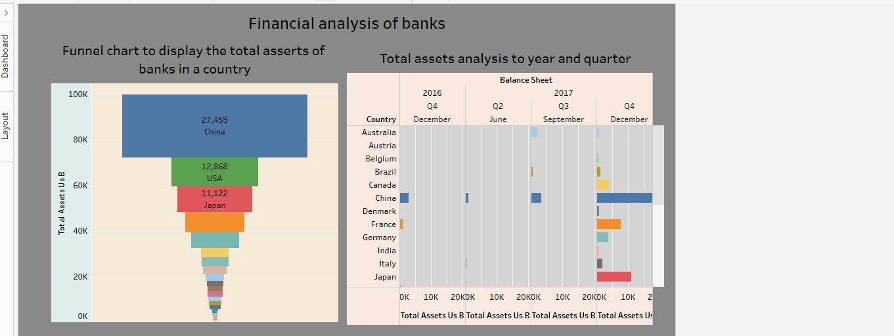

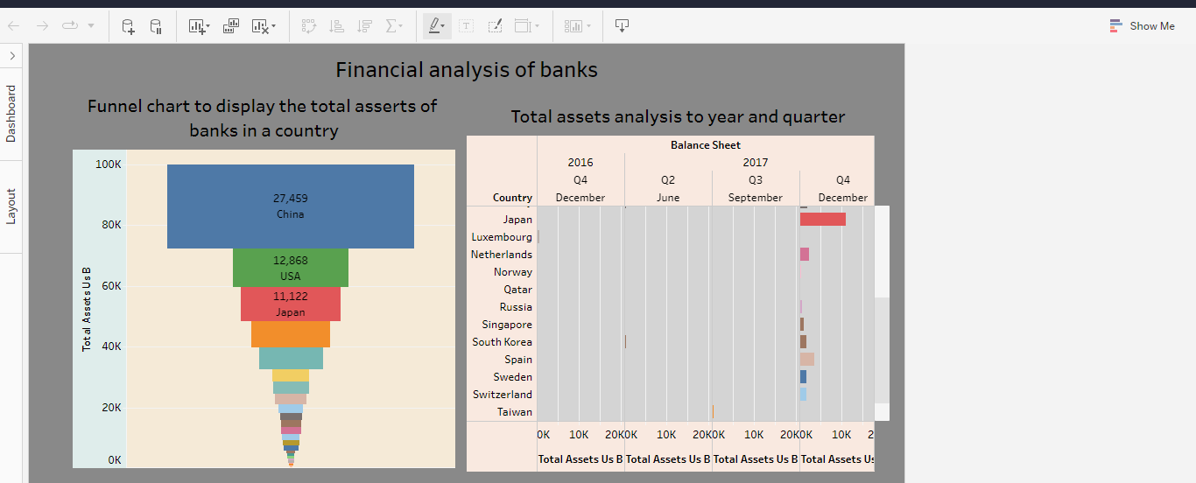

Story:

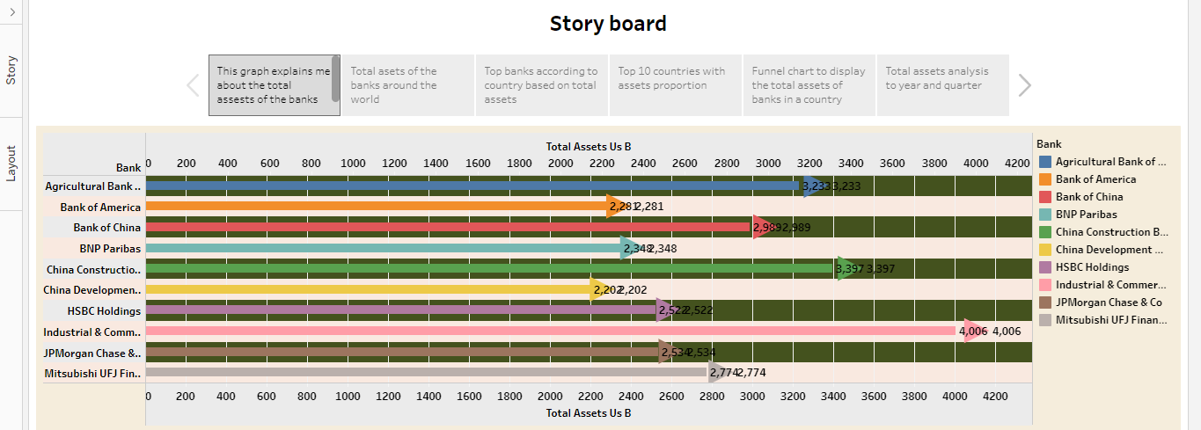

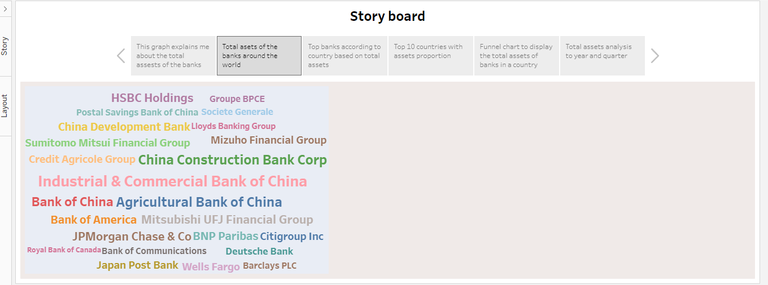

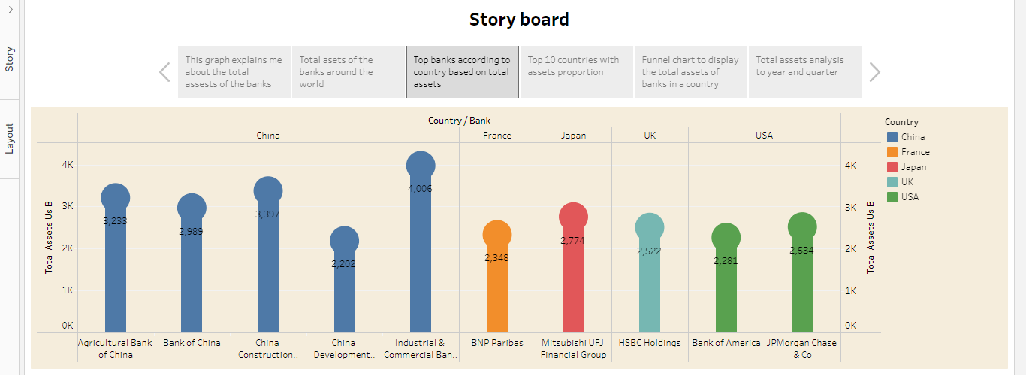

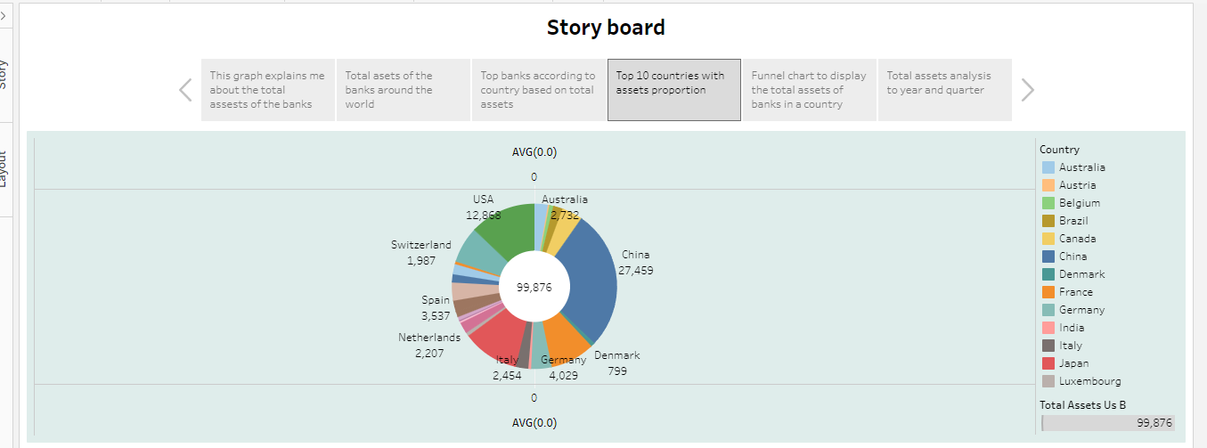

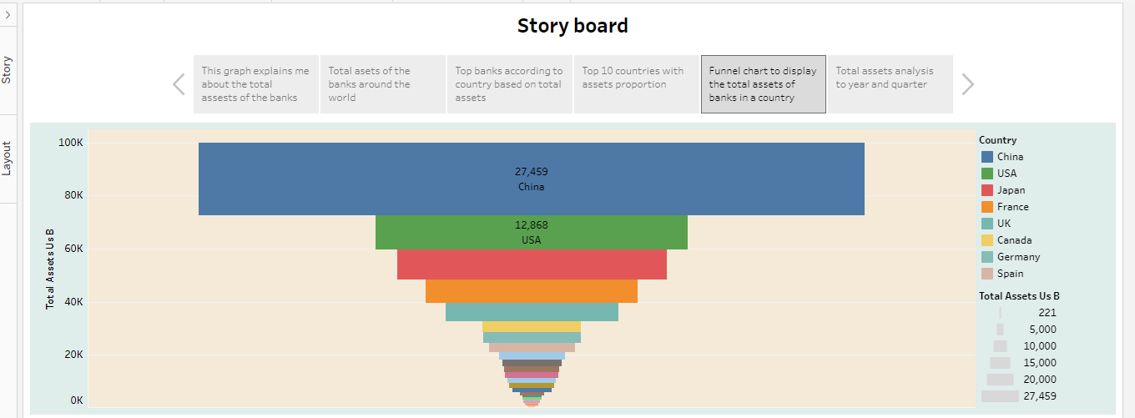

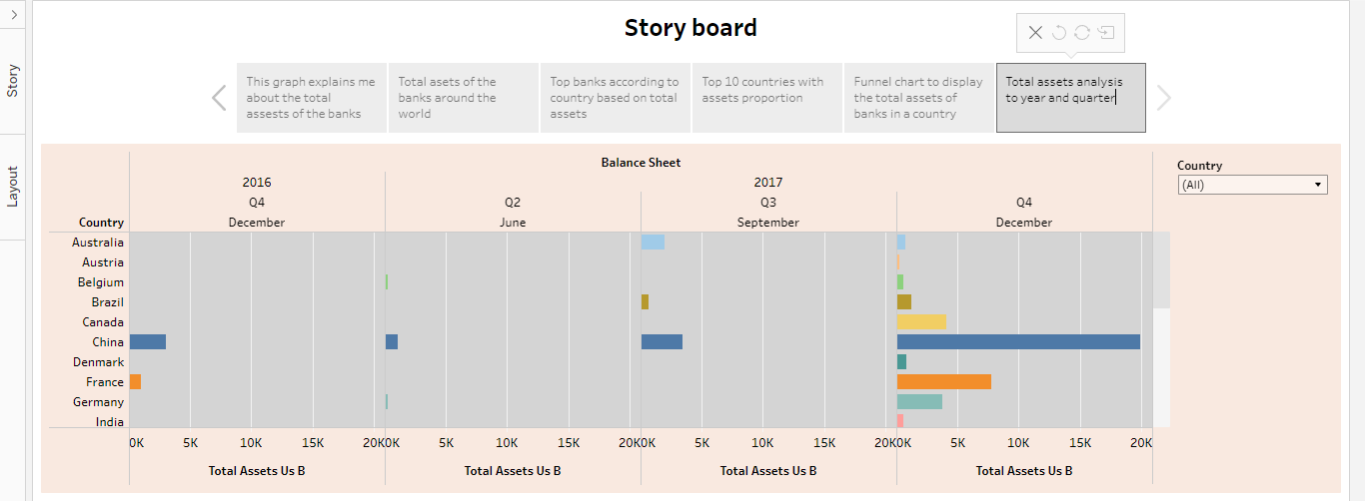

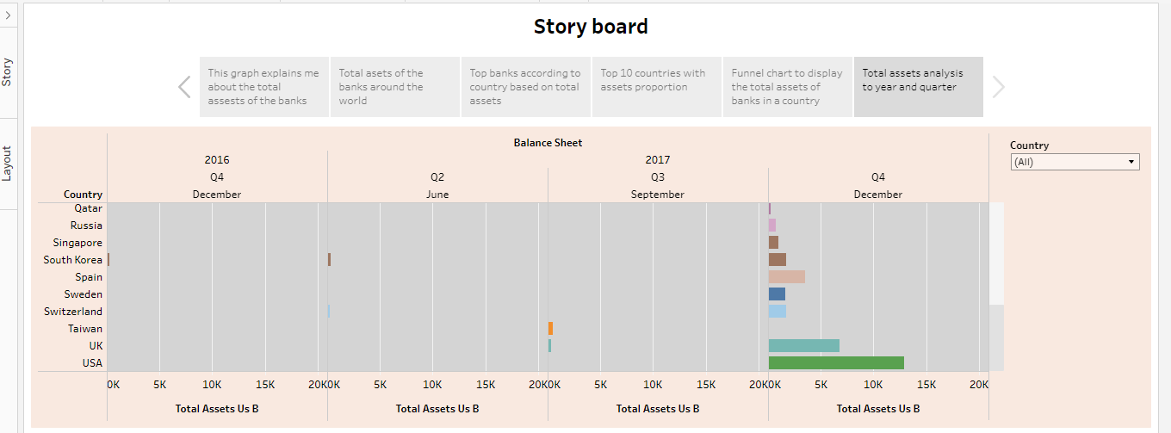

4. Advantage and Disadvantage:

**The advantages of analysis of financial performance are as follows:**

**The ability to detect patterns:**

Financial statement reveal how much a company earns per year in sales. The sales may fluctuate, but financial planners should be able to identify a pattern over years of sales figures. For example, the company may have a pattern of increased sales when a new product is released.

**A chance to budget outline:**

Another advantage of using financial statement for future planning and decision making is that they show the company’s budgets. The budgets reveal how much wiggle room the company has to spend on launching products, developing marketing campaigns or expanding the current office size.

**The Disadvantages of analysis of financial performance are as follows:**

**Based on Market patterns:**

A disadvantage of using financial statements for decision making is that the data and figures are based on the market at the given time. Depending on the market, it may change quickly, so excutives should not assume that the numbers from a previous financial statement will remain the same are increase.

**At- one-time Analysis:**

Another disadvantage is that a single financial statement only shows how a company is doing at one single time. The financial statement thus not show whether the company is doing better or worse than the year before.

**5. Application:**

**Financial performance analysis:**

An introduction described a framework for conducting a financial performance analysis. Consistent with the framework, prior to undertaking any analysis , an analyst should explore the purpose of context of the analysis. The purpose and context guide further decisions about the approach, the tools, the data sources, and the format in which to report results of the analysis, and suggest which aspects of the analysis are most important.

**6. Conclusion:**

Financial performance analysis determines a company’s health and stability, providing an understanding of how the company conducts its business. But it is important to know that financial performance analysis has its limitation as well. Different according methods adopted by different firms changes the visible health and profit levels for either better or worse. Different analysts may get different results from the same the information. Hence, we must conclude that financial performance analysis in banks is only one of the tools while taking an investment decisions.

**7.Future Scope:**

The study is based on the financial position of the firm by using ratio analysis, trend analysis and comparative statements. Financial statements help the management to analyse profit, solvency, liquidity and efficiency, etc. This analysis will give the exact picture of the company.

**8. Appendix:**

<!DOCTYPE html>

<html lang="en-US">

<head>

<meta charset="utf-8" />

<meta name="viewport" content="width=device-width" />

<title>My Test Page</title>

</head>

<body>

<h1>A comprehensive analysis of financial performance: Insights from a leading banks.</h1>

<Introduction:>

This session introduces bank financial statement and provides a traditional,ratio-base procedure for analyzing bank financial performance using historical data. It demonstrates the interrelationship between the income statement and balance sheet and describes the risk and return trade-off underlying management decisions. Data are provided that compare the performance characteristics of small banks verus large banks and differentiate between high and low performance.

Financial performance analysis is multifaceted approach to evaluating a company’s financial performance. It is the process of examining a business enterprise’s financial records,statement ,tools,and process. Here are some of the things financial performance analysis looks at:

* Working capital: It is the difference between the companies’ current assets and liability.
* Financial structure: It is the mix of equality and other portfolios offered by the company.
* Analyzing activities: It analyses business functions like costing, pricing,accounts,etc.

<h1>Dashboard & Story</h1>

<div class='tableauPlaceholder' id='viz1681399603802' style='position: relative'><noscript><a href='#'><img alt=' ' src='https:&#47;&#47;public.tableau.com&#47;static&#47;images&#47;ba&#47;bankingproject_16812345163630&#47;Dashboard1&#47;1_rss.png' style='border: none' /></a></noscript><object class='tableauViz' style='display:none;'><param name='host_url' value='https%3A%2F%2Fpublic.tableau.com%2F' /> <param name='embed_code_version' value='3' /> <param name='site_root' value='' /><param name='name' value='bankingproject_16812345163630&#47;Dashboard1' /><param name='tabs' value='yes' /><param name='toolbar' value='yes' /><param name='static_image' value='https:&#47;&#47;public.tableau.com&#47;static&#47;images&#47;ba&#47;bankingproject_16812345163630&#47;Dashboard1&#47;1.png' /> <param name='animate_transition' value='yes' /><param name='display_static_image' value='yes' /><param name='display_spinner' value='yes' /><param name='display_overlay' value='yes' /><param name='display_count' value='yes' /><param name='language' value='en-US' /></object></div> <script type='text/javascript'> var divElement = document.getElementById('viz1681399603802'); var vizElement = divElement.getElementsByTagName('object')[0]; if ( divElement.offsetWidth > 800 ) { vizElement.style.minWidth='1500px';vizElement.style.maxWidth='100%';vizElement.style.minHeight='850px';vizElement.style.maxHeight=(divElement.offsetWidth*0.75)+'px';} else if ( divElement.offsetWidth > 500 ) { vizElement.style.minWidth='1500px';vizElement.style.maxWidth='100%';vizElement.style.minHeight='850px';vizElement.style.maxHeight=(divElement.offsetWidth*0.75)+'px';} else { vizElement.style.width='100%';vizElement.style.minHeight='800px';vizElement.style.maxHeight=(divElement.offsetWidth*1.77)+'px';} var scriptElement = document.createElement('script'); scriptElement.src = 'https://public.tableau.com/javascripts/api/viz_v1.js'; vizElement.parentNode.insertBefore(scriptElement, vizElement); </script>

<h2>Conclusion</h2>

Financial performance analysis determines a company’s health and stability, providing an understanding of how the company conducts its business. But it is important to know that financial performance analysis has its limitation as well. Different according methods adopted by different firms changes the visible health and profit levels for either better or worse. Different analysts may get different results from the same the information. Hence, we must conclude that financial performance analysis in banks is only one of the tools while taking an investment decisions.